Republic of the Philippines Province of Cebu

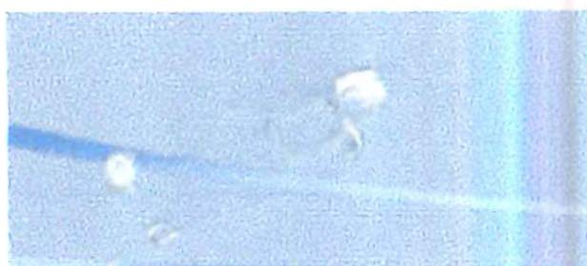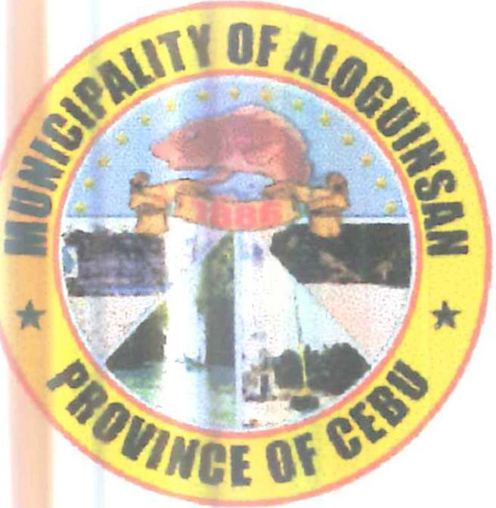

# MUNICIPALITY OF ALOGUINSAN

Municipal Hall Building Poblacion,Aloguinsan,Cebu Tel. No. (032) 436-6345

-000-

# OFFICE OF THE MUNICIPAL MAYOR

**EXECUTIVE ORDER NO.**

Series of 2025

# AN ORDER RECONSTITUTING THE MUNICIPAL DISASTER RISK REDUCTION AND MANAGEMENT COUNCIL (MDRRMC) OF THE MUNICIPALITY OF ALOGUINSAN, CEBU.

**WHEREAS,** it is a declared policy of the state to uphold the people's constitutional rights to life and property by addressing the root causes of vulnerabilities to disasters, risk reduction and management and building the resilience of local communities to disasters including climate change impacts;

**WHEREAS,** under Section 468 (a)(l)(iv) of R.A. No. 7160, it is the duty of the Municipal Government to adopt measures to protect the inhabitants of the Municipality from the harmful effects of man-made or natural disasters and calamities and to provide relief services and assistance for victims during and in the aftermath of said disaster and calamities;

**WHEREAS,** Republic Act No. 10121 was enacted by Congress on February 01, 2010 also known as the "Philippine Disaster Risk Reduction and Management Act of 2010";

**WHEREAS,** Section 11 of the aforesaid law provides for the organization of the local government level of the Disaster Risk Reduction and Management Council and accordingly the existing Municipal Disaster Coordinating Council (MDCC), under P.O. 1566, shall henceforth be known as Municipal Disaster Risk Reduction and Management Council (MDRRMC);

**WHEREAS,** there is a need to reconstitute and strengthen the existing MDRRMC in order to enhance a coherent, integrated, proficient and responsible management system in the Municipality. They shall also coordinate and implement projects and activities on civil protection, standard human assistance, and disaster management;

**NOW, THEREFORE, I, CESARE IGNATIUS G. MORENO,** Municipal Mayor of the

Municipality of Aloguinsan, Cebu, by virtue of the powers vested in me by law, do hereby order the reconstitution of the composition of the Municipal Disaster Risk Reduction and Management Council (MDRRMC) of the Municipality of Aloguinsan, Cebu, to viz:

**SECTION 1. COMPOSITION.** The Municipal Disaster Risk Reduction and Management Council (MDRRMC) of the Municipality of Aloguinsan, Cebu shall be Chaired by HON. CESARE IGNATIUS G. MORENO (Municipal Mayor) and Vice Chaired by HON. CHRISTIAN G. MORENO (Municipal Vice Mayor), with the following as Members:

1. CESARE IGNATIUS G. MORENO (Mayor, Chairman of LDRRM Council)
2. CHRISTIAN G. MORENO (Vice Mayor, Vice Chairman of LDRRM Council)
3. ROY MANGUILIMOTAN (SB Member, Disaster Preparedness)
4. NACIANZINO MANIGOS (SB Member, Chairman of the Committee on Budget, Appropriation and Finance, and Ways and Means)
5. MICHAEL E. PABROA (SB Member, Chairman of the Committee on Environmental Protection)
6. SHANE M. NAVARRO (Local Disaster Risk Reduction and Management Officer)
7. JOHN PAUL DINOPOL (Municipal Planning and Development Coordinator)
8. MELVIH TUMAKAY (Municipal Budget Officer)
9. SATURNINO PATATAG JR. (Municipal Accountant)
10. MARILOU ARANTE (Municipal Treasurer)
11. ENGR. ENGELBERTO G. ATIL II (Municipal Engineer)
12. ARIEL ARANTE (MENRO/MAO Designate)
13. DR. GIMBERT ESCASINAS (Municipal Health Officer)
14. MARIA CORAZON RICAFORTE (Municipal Social Welfare and Development Officer)
15. ROY BENDANILLO (Municipal Assessor)
16. DENNIS ITOM (MLGOO)
17. ALEXANDER BRIGOLI (President Liga ng Barangay)
18. FATIMA SOLIS (Local DepEd Supervisor)
19. DIOGRIO IJURPE (DepEd DRR Coordinator)
20. MA. ELDICYN ALBURO (Municipal Fire Marshall)
21. LEOVIL SINGSON (Chief of Police, Aloguinsan Police Station)
22. NOEL UROT (Officer-in-Charged, Philippine Army Aloguinsan Detachment)
23. ALMAMITO PANCHO JR. (Aloguinsan Vendors Association)
24. BLAZER DELOS SANTOS (DRRMH Focal)
25. JOJIE CUYNO (Kantabogon Ecotourism Association)
26. MERELYN DALES (Akapin Sugbo)
27. RUDNEY CARCUEVAS (Bojo Aloguinsan Ecotourism Association)
28. JOCELYN LAPINGCAO (Rosario Farmers Association)

cc) STEVE LAWRENCE TIBON (SKF President)

dd) MITCHEL IGNARIO (Municipal Admin)

ee) GERALDINE MACABENTA (LYDO)

**SECTION 2. FUNCTIONS.** The Municipal Disaster Risk Reduction and Management Council shall perform the following functions:

1. Approve, monitor, and evaluate the implementation of the Municipal Disaster Risk Reduction and Management Plan and annually review, test, and develop the plan consistent with other national and local planning programs;
2. Ensure the integration of disaster risk reduction and climate change adaptation into local development plans, programs, and budgets as a strategy in sustainable development and poverty reduction;
3. Recommend the implementation of forced or pre-emptive evacuation of local residents, if necessary and
4. Convene once every three (3) months, or as necessary.

**SECTION 3. EFFECTIVITY.** This Order shall take effect immediately upon issuance. Issued this 11th day of September 2025 at the Municipal Hall Building, Barangay Poblacion, Aloguinsan, Cebu.

**CESARE IGNATIUS G. MORENO**

Municipal Mayor

Copy furnished:

All concerned